-- Q1 Write an SQL query to report the managers with at least five direct

reports.

SELECT Name FROM q1

WHERE Id IN

(SELECT ManagerId FROM q1

GROUP BY ManagerId

HAVING count(Id) >= 5);

OUTPUT

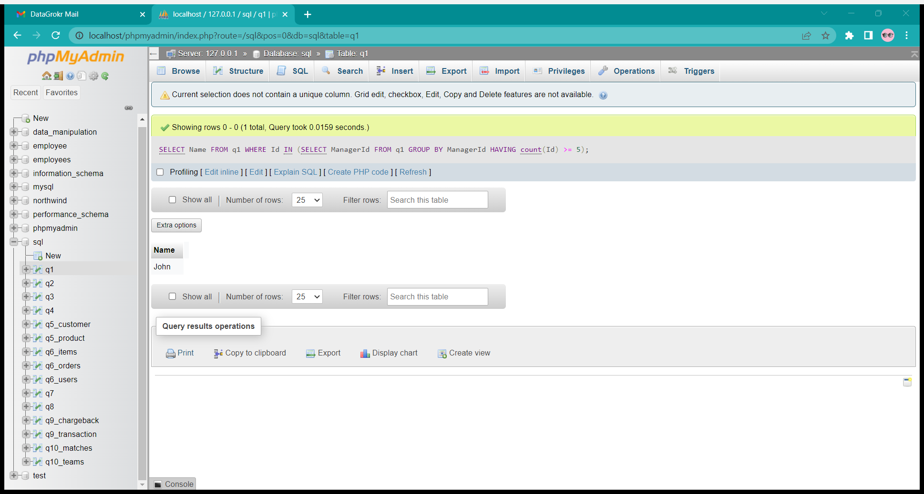

TABLE



-- Q2 Write an SQL query to report the nth highest salary from the Employee

table. If there is no nth highest salary, the query should report null.

select * from ((select * from q2

ORDER BY salary DESC limit 2 ) AS T) --2nd highest

ORDER BY T.salary ASC limit 1;

OUTPUT

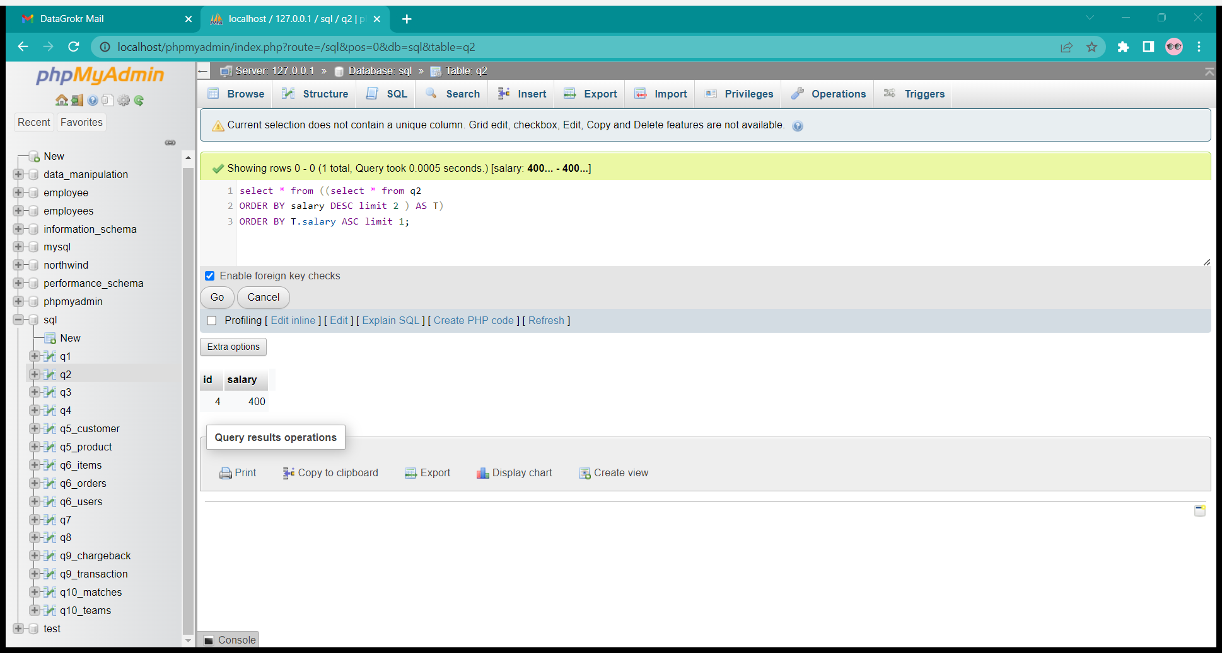

TABLE

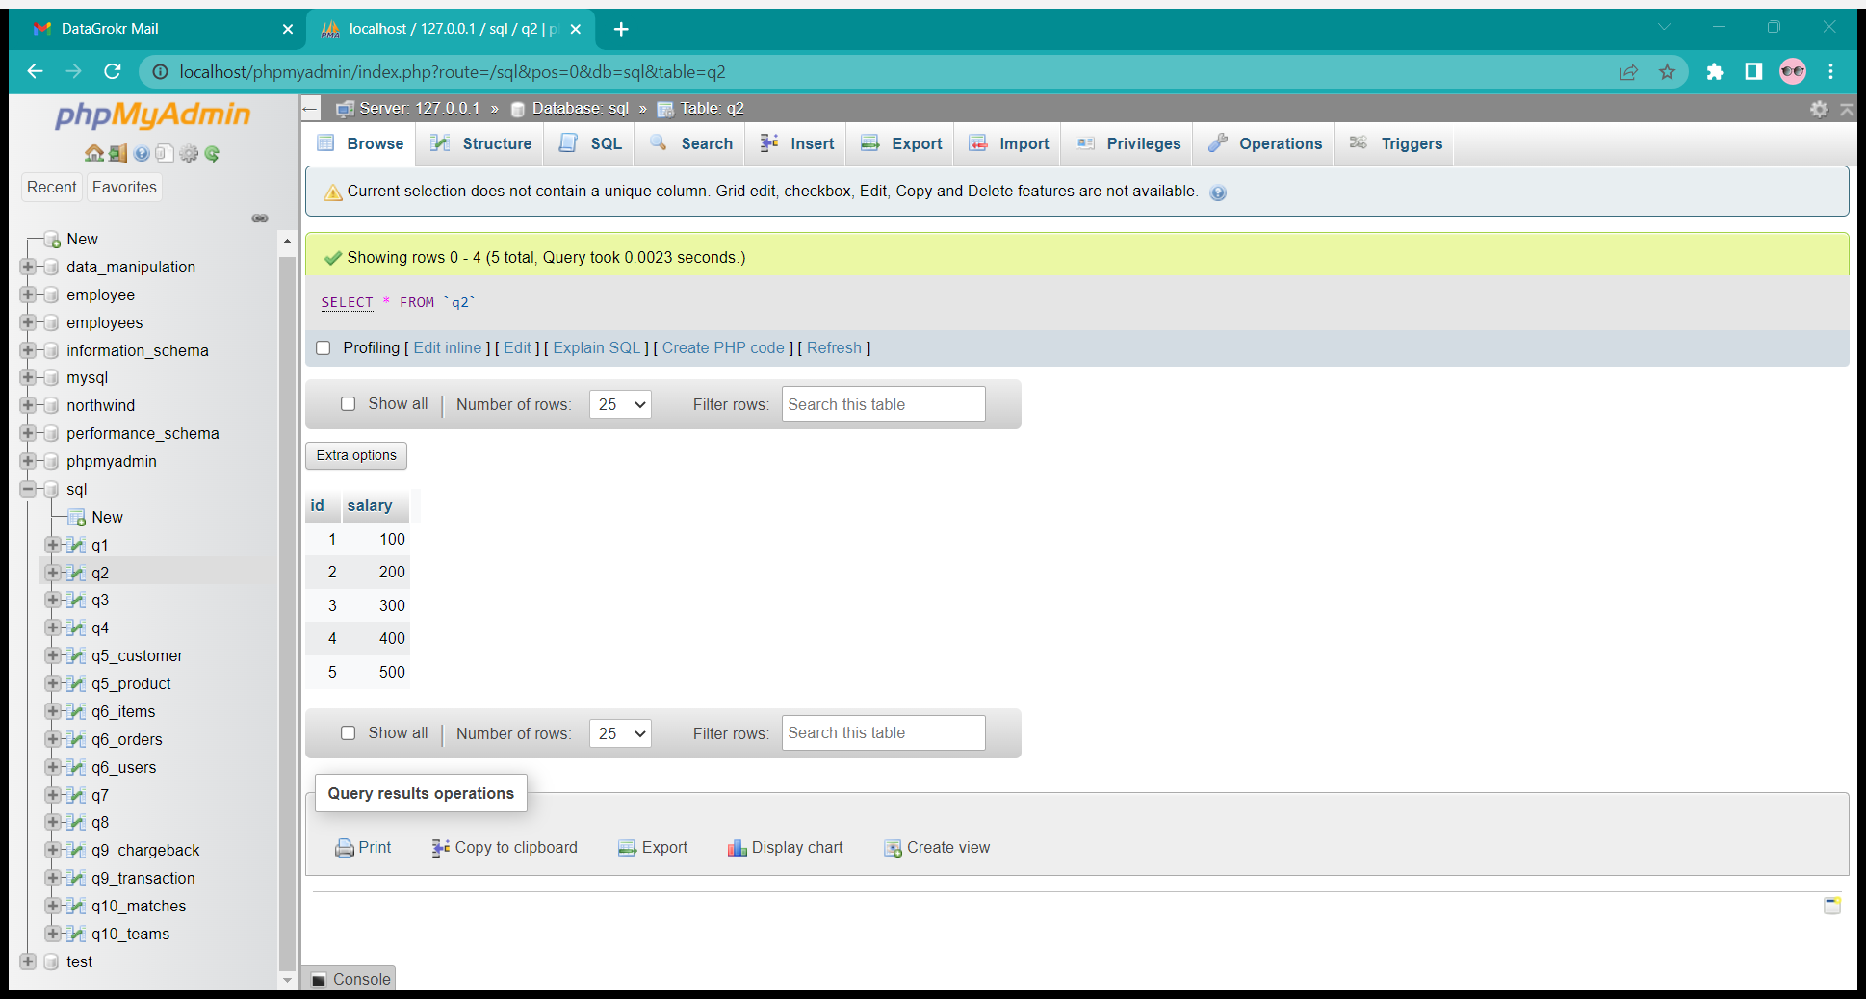

-- Q3 Write an SQL query to find the people who have the most friends and the

most friends number

select id, count(*) as num from (

    select requester_id as id from q3

    union all

    select accepter_id from q3

) as f_cnt

group by id

order by num desc limit 1;

OUTPUT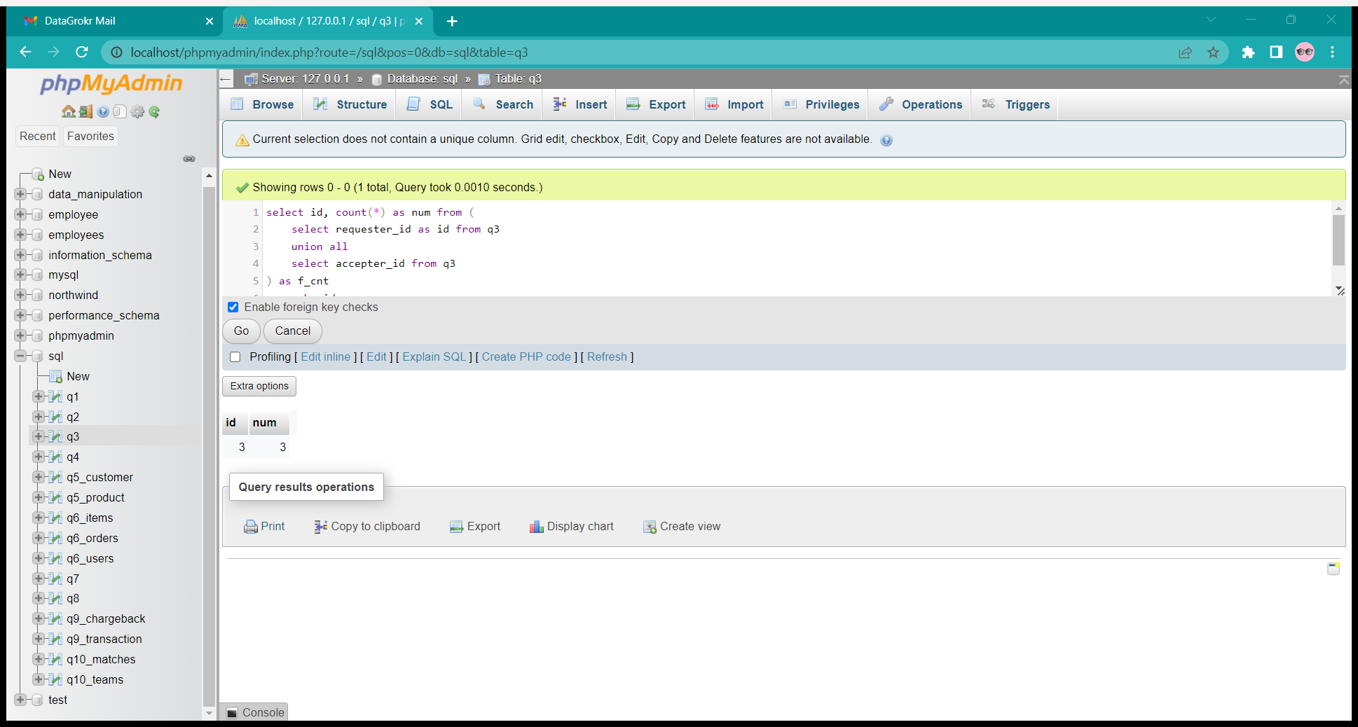

TABLE

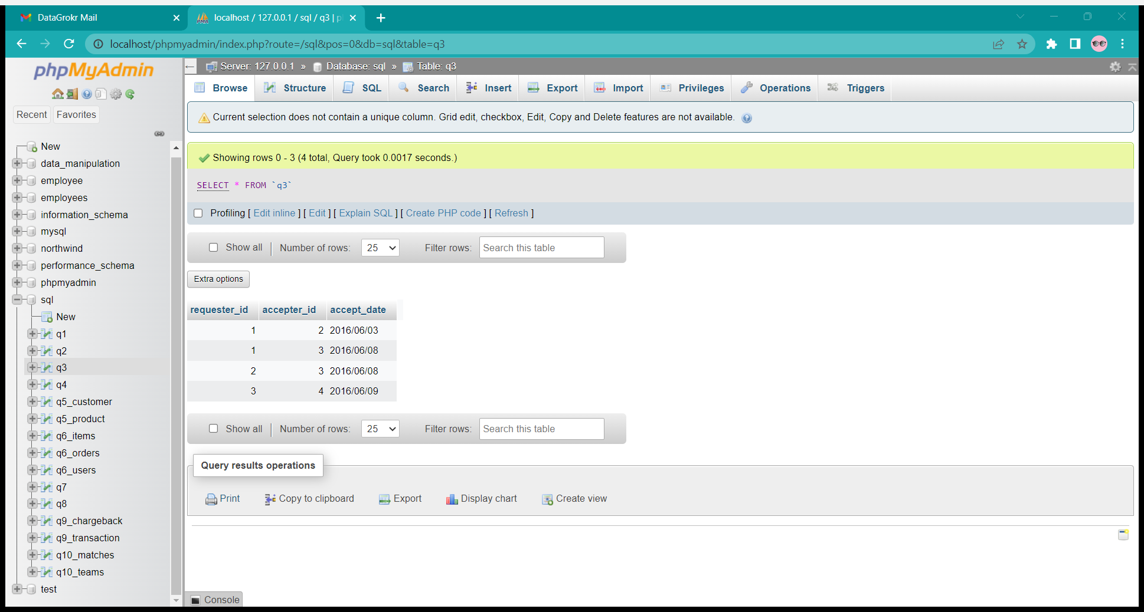

-- Q4 Write an SQL query to swap the seat id of every two consecutive

students. If the number of students is odd, the id of the last student is not swapped.

SELECT ( CASE

            WHEN id%2 != 0 AND id != counts THEN id+1  -- for odd ids

            WHEN id%2 != 0 AND id = counts THEN id  -- special case for last seat

            ELSE id-1   -- For even ids

        END) AS id, name

FROM q4, (select count(*) as counts from q4)

AS seat_counts

ORDER BY id ASC;

OUTPUT

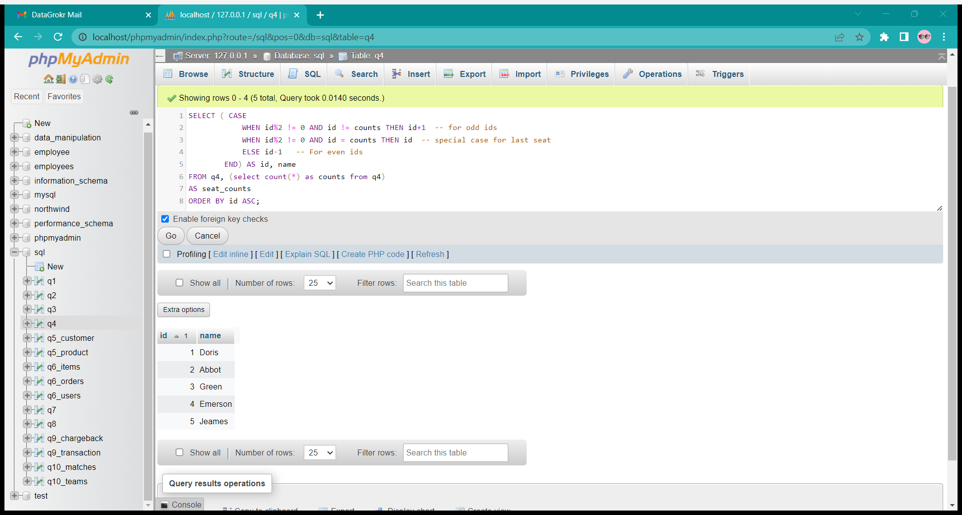

TABLE

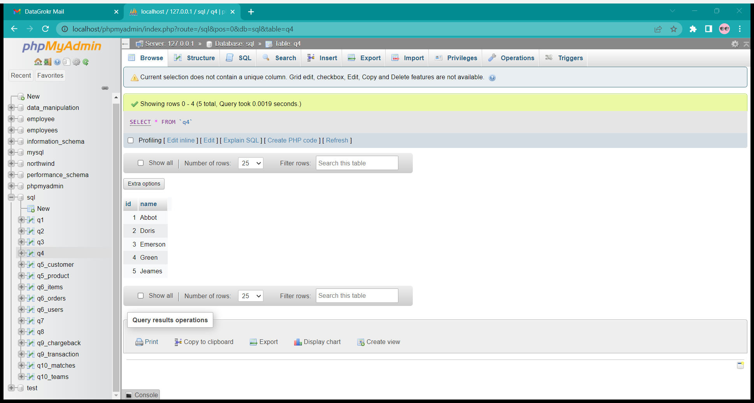

-- Q5 Write an SQL query to report the customer ids from the Customer table

that bought all the products in the Product table

SELECT

    customer_id

FROM q5_customer

GROUP BY customer_id

HAVING COUNT( DISTINCT product_key) = (SELECT COUNT(*) FROM q5_product);

GROUP BY customer_id

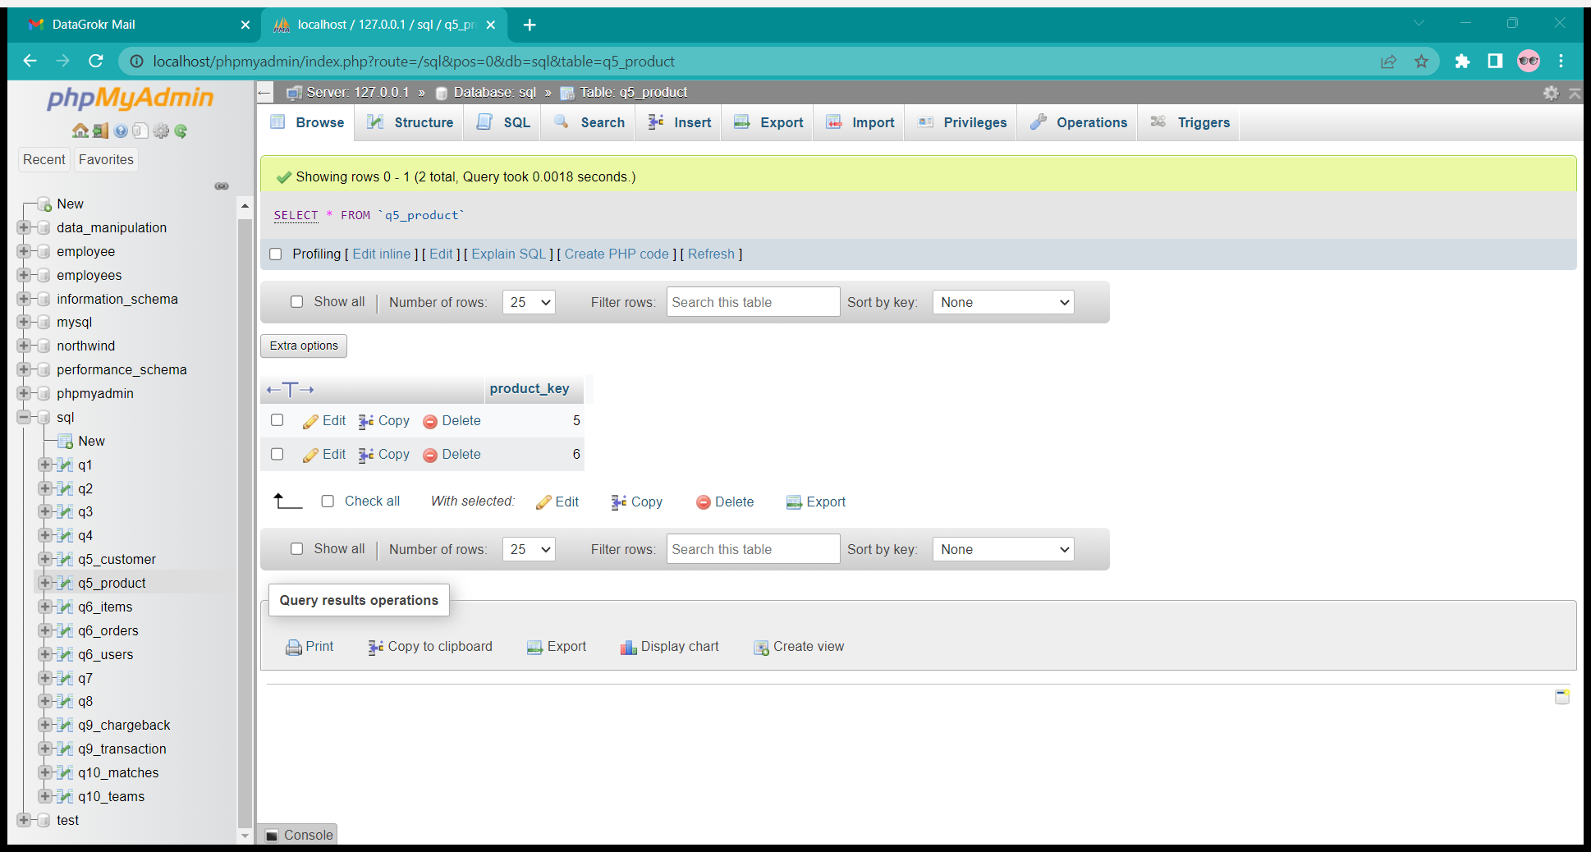

TABLES

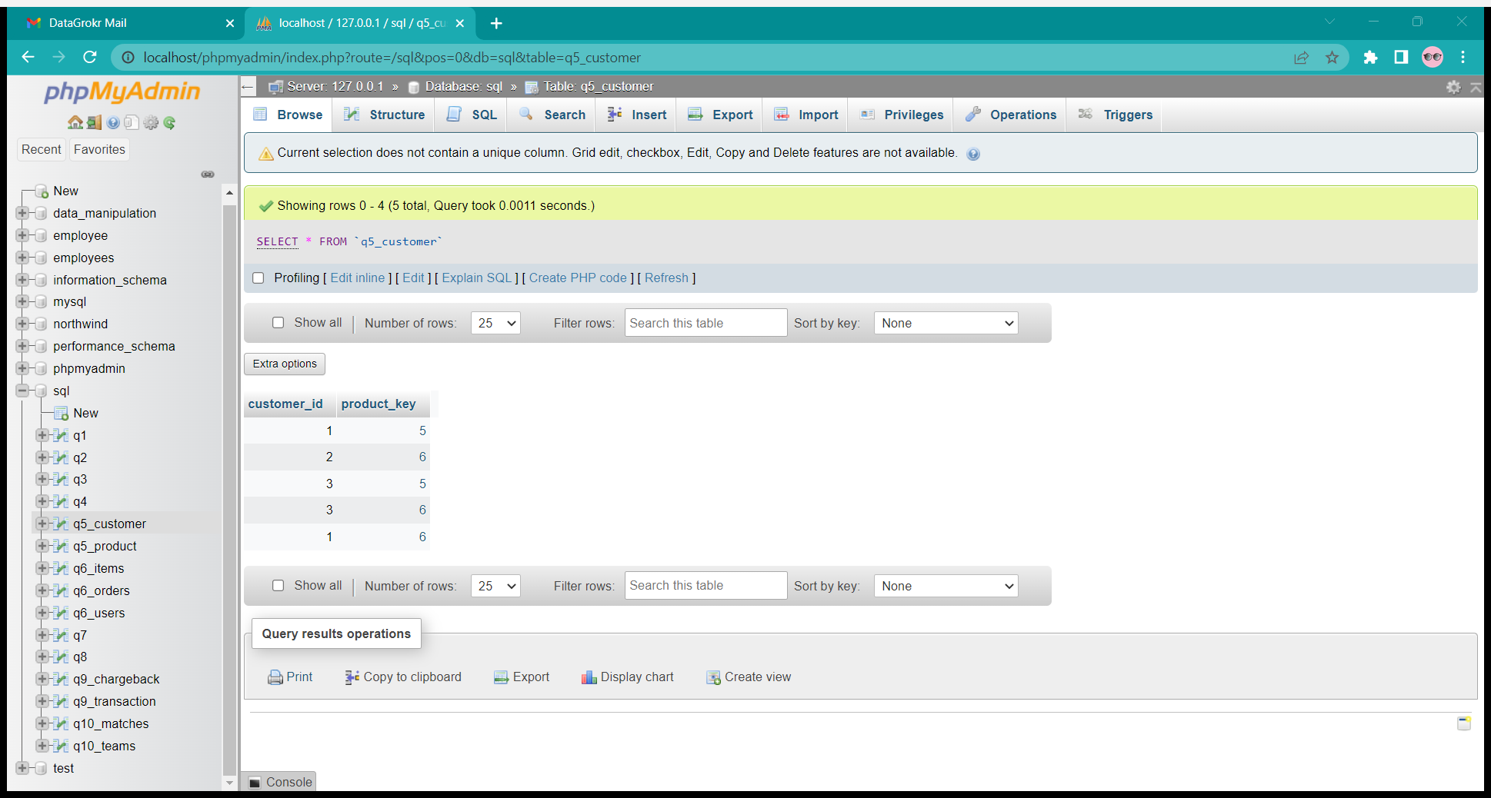

OUTPUT

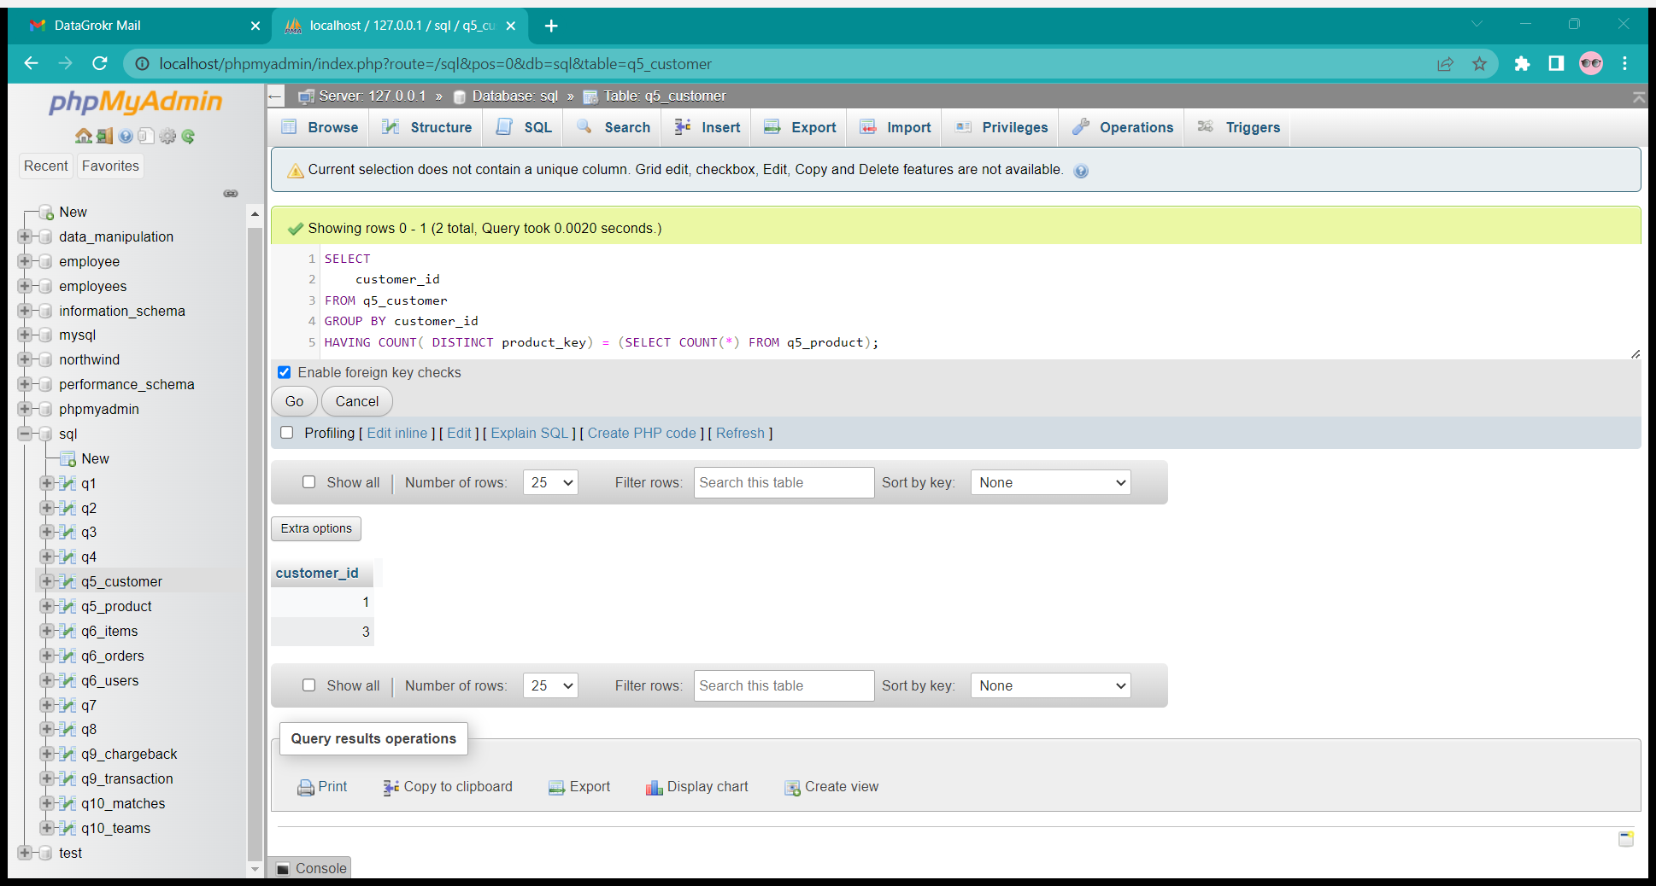

-- Q6 Write an SQL query to find for each user, the join date and the number

of orders they made as a buyer in 2019.

select user_id as buyer_id, join_date,

    sum(case when order_id is not null then 1 else 0 end) as orders_in_2019

from q6_users

left join q6_orders on q6_users.user_id = q6_orders.buyer_id

and year(order_date) = 2019

group by user_id, join_date

order by buyer_id;

OUTPUT

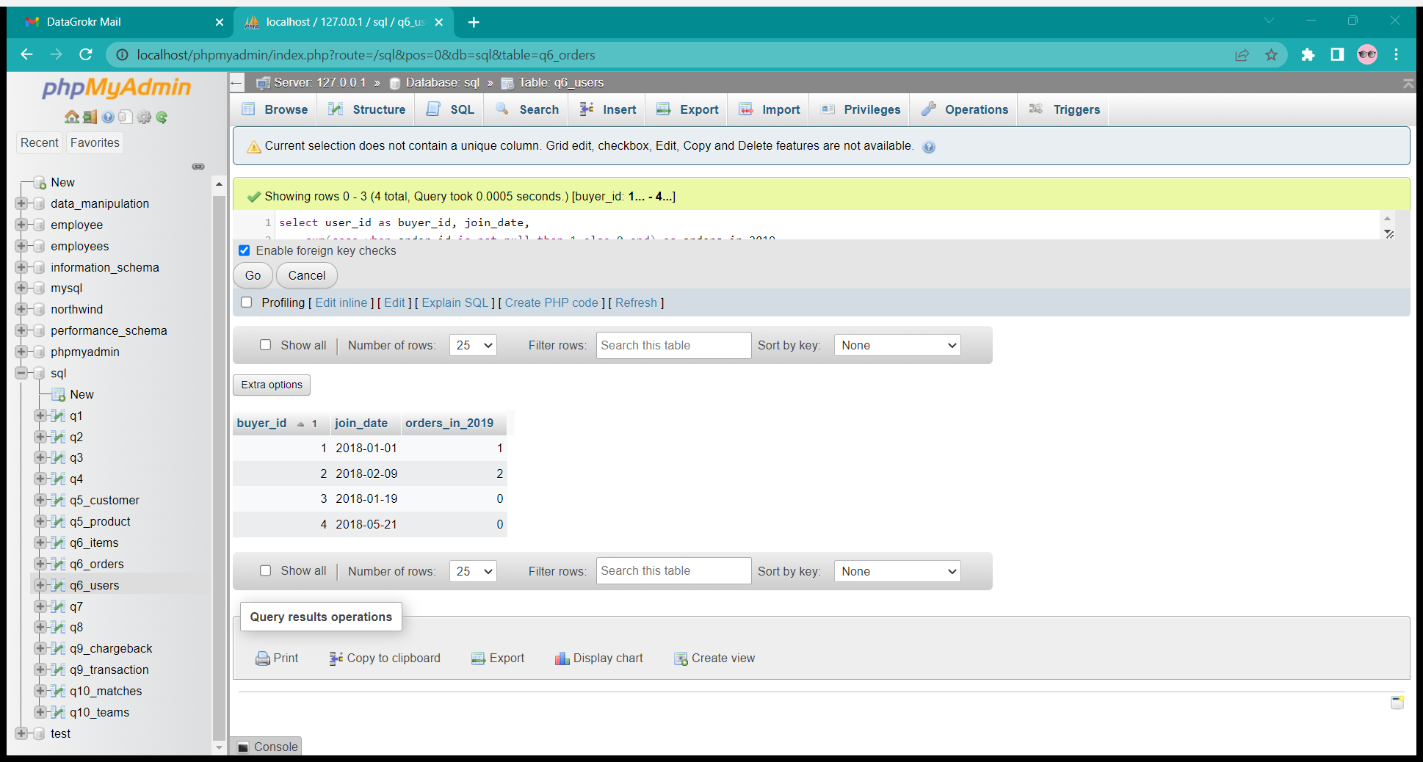

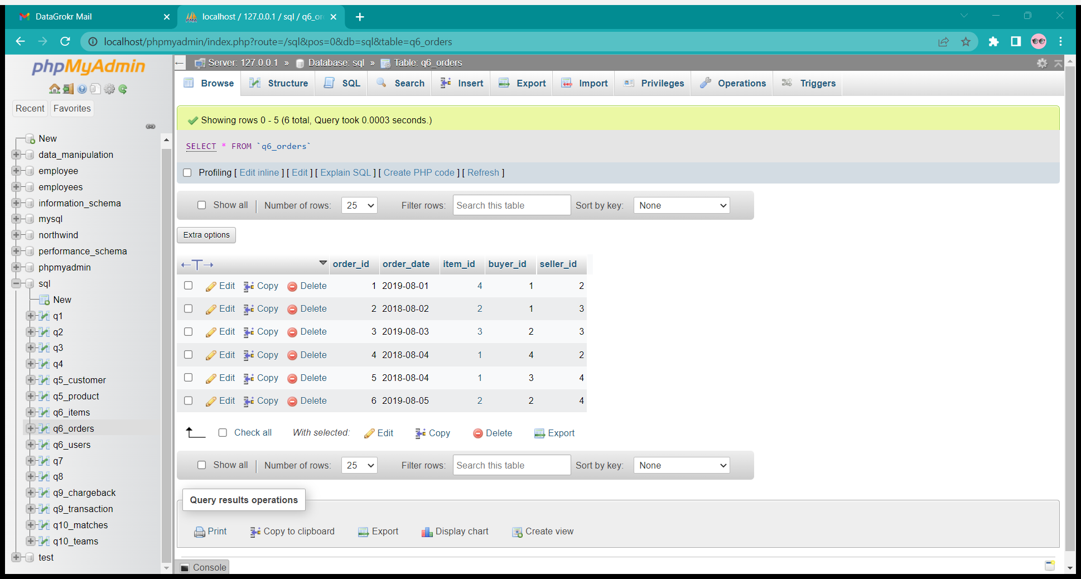

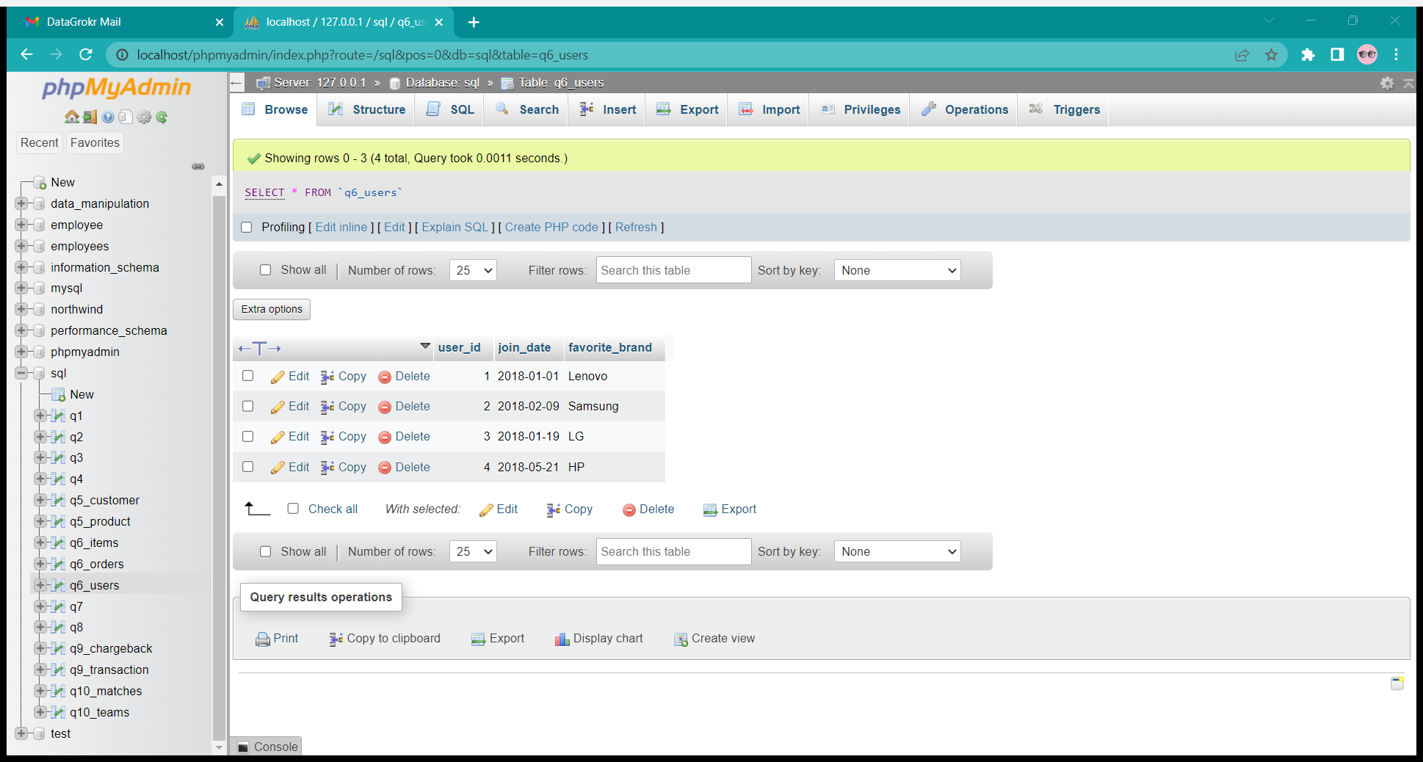

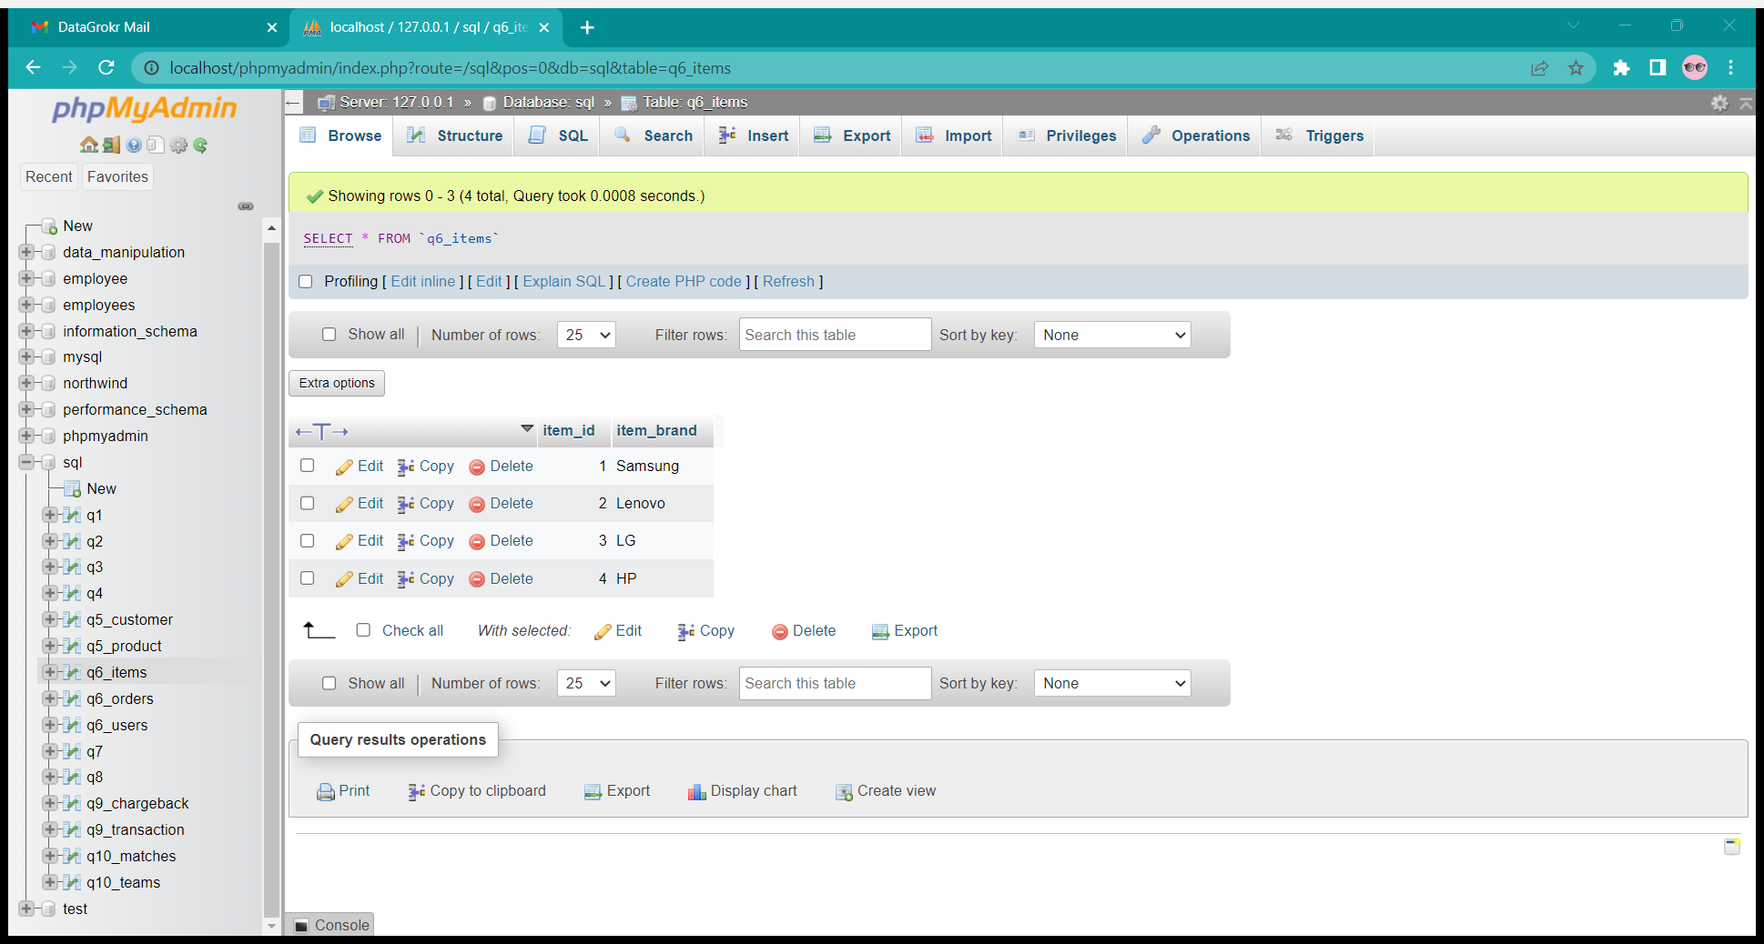

TABLES

-- Q7 Write an SQL query to reports for every date within at most 90 days from

today, the number of users that logged in for the first time on that date. Assume today is 2019-06-30.

SELECT login_date, COUNT(user_id) user_count

FROM

    (SELECT user_id,activity_date as login_date

    FROM q7

    WHERE activity='login'

    GROUP BY user_id) as t

WHERE DATEDIFF('2019-06-30', login_date) <= 90

GROUP BY login_date;

OUTPUT

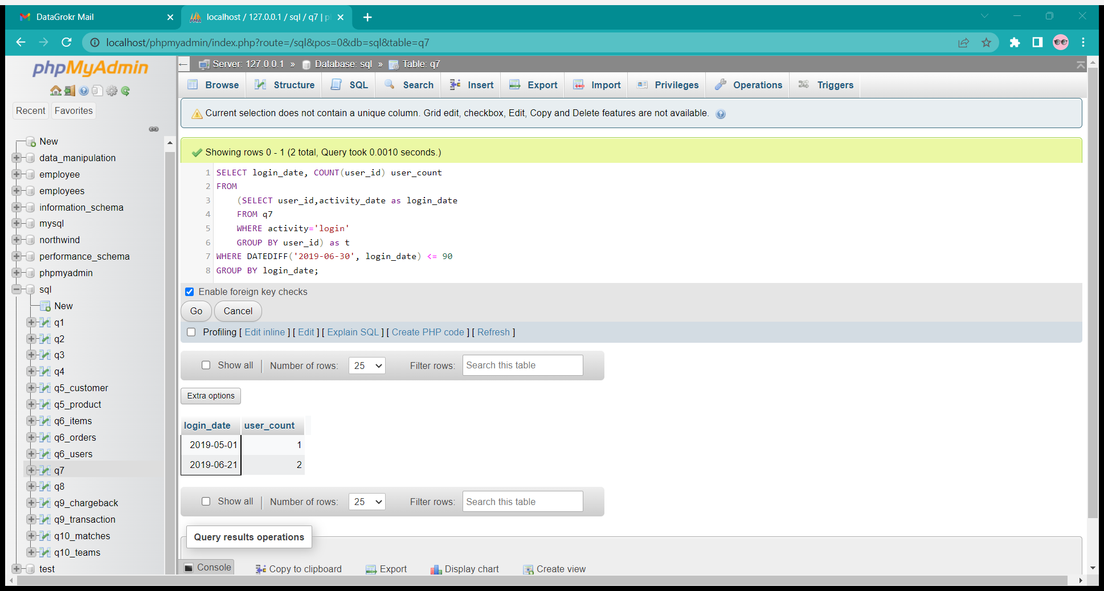

TABLE

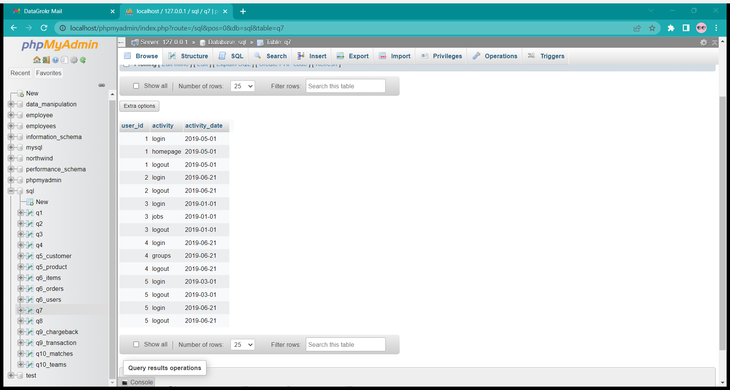

-- Q8 Write an SQL query to find the prices of all products on 2019-08-16.

Assume the price of all products before any change is 10.

select * from (

    select product_id, new_price as price from q8

        where (product_id, change_date) in (

            select product_id, max(change_date) from q8

                where change_date <= '2019-08-16'

                group by product_id

        )

    union

        select distinct product_id, 10 as price from q8

            where product_id not in (

                select product_id from q8

                    where change_date <= '2019-08-16'

            )

    ) union_result;

OUTPUT

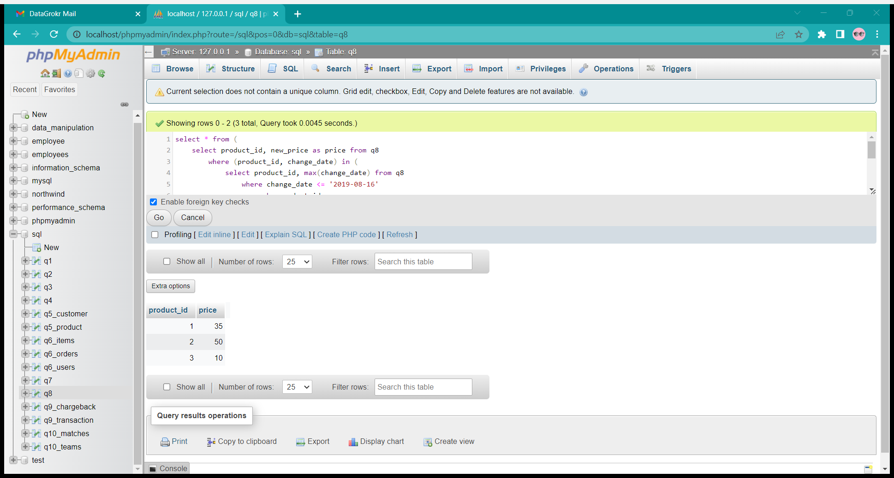

TABLE

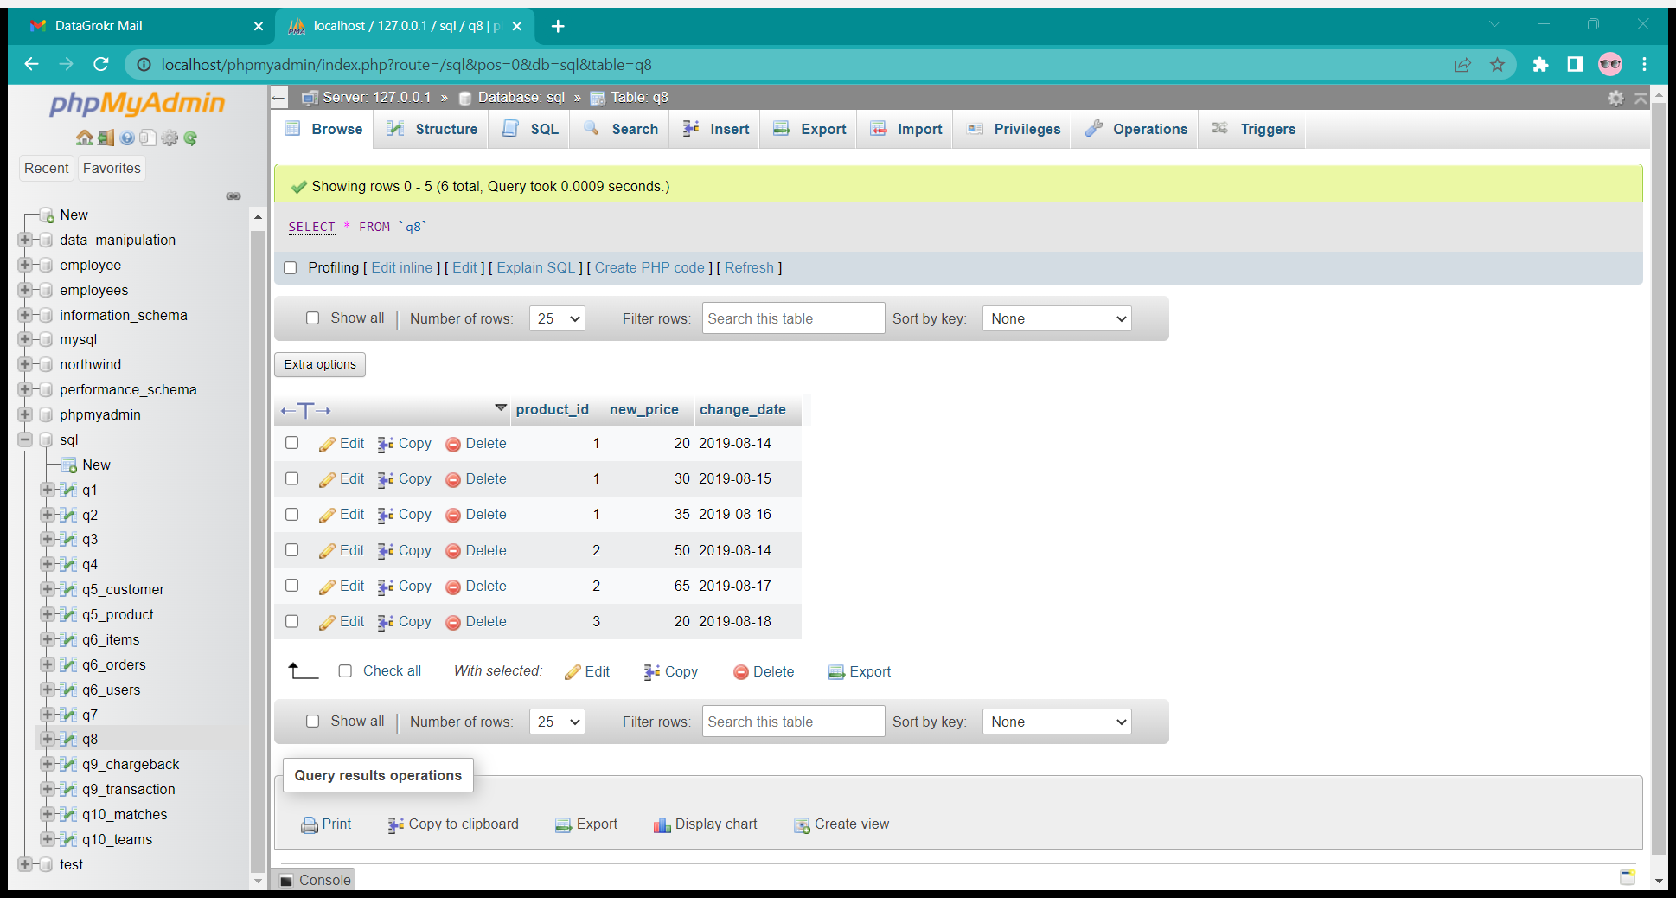

-- Q9 Write an SQL query to find for each month and country: the number of

approved transactions and their total amount, the number of chargebacks, and their total amount.

select month, country,

    sum(case when type='approved' then 1 else 0 end) as approved_count,

    sum(case when type='approved' then amount else 0 end) as approved_amount,

    sum(case when type='chargeback' then 1 else 0 end) as chargeback_count,

    sum(case when type='chargeback' then amount else 0 end) as chargeback_amount

from (

    (

    select left(t.trans_date, 7) as month, t.country, amount,'approved' as type

    from q9_transaction as t

    where state='approved'

    )

    union all (

    select left(c.trans_date, 7) as month, t.country, amount,'chargeback' as type

    from q9_transaction as t join q9_chargeback as c

    on t.id = c.trans_id

    )

) as tt

group by tt.month, tt.country;

TABLES

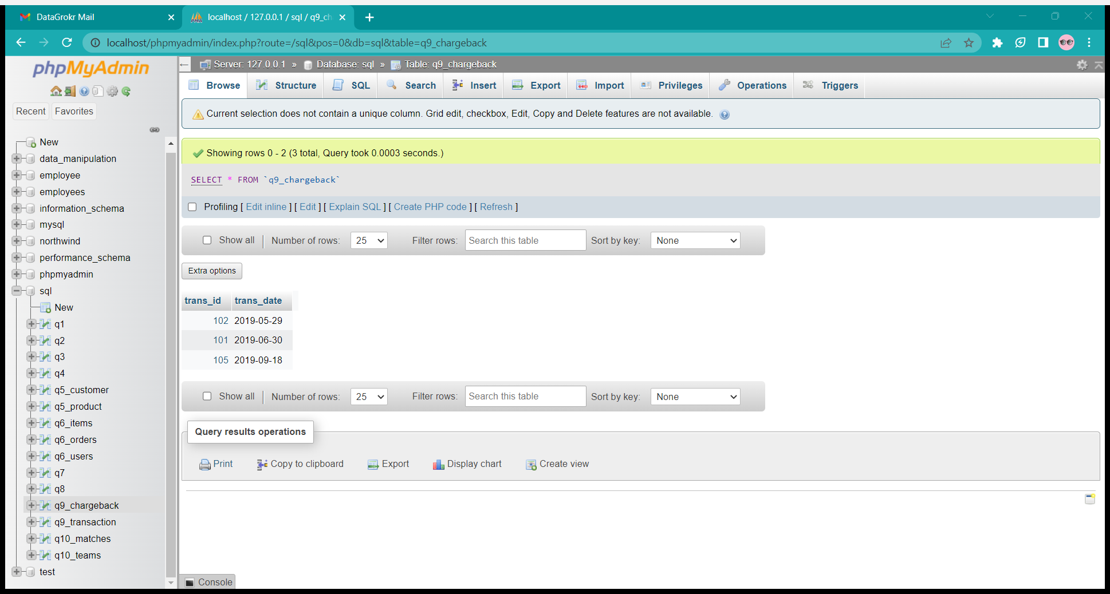

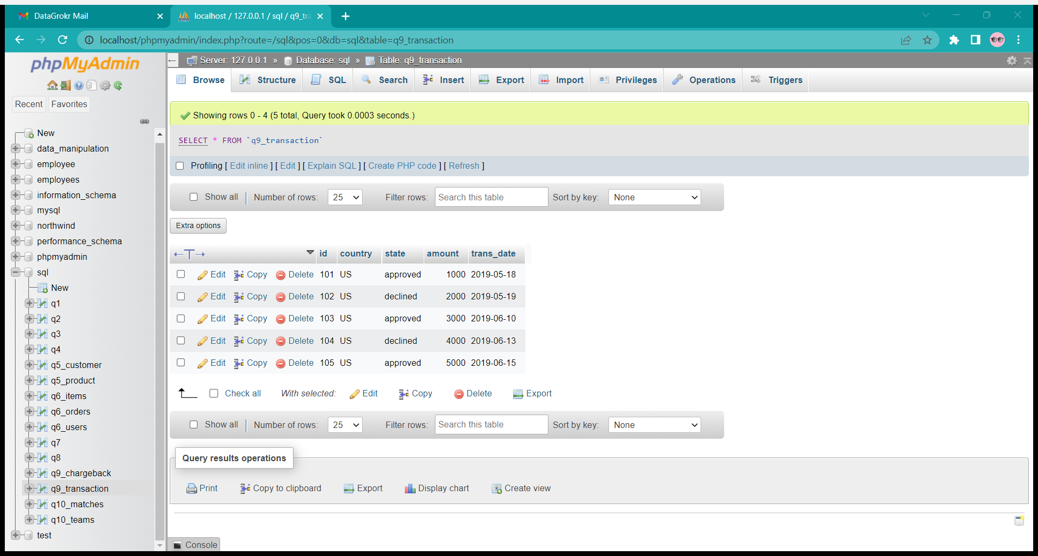

OUTPUT

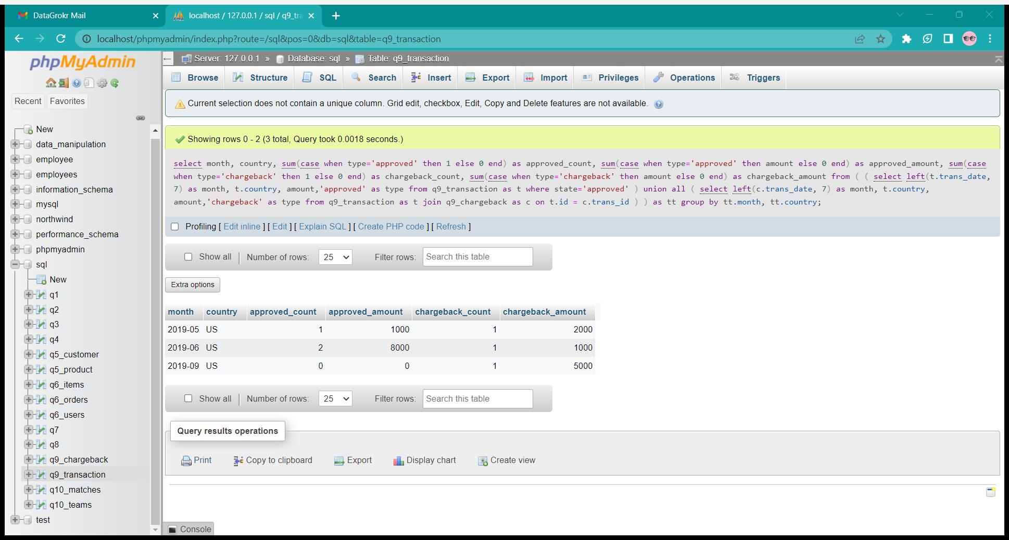

-- Q 10  Write an SQL query that selects the team_id, team_name and num_points

of each team in the tournament after all described matches.

select q10_teams.team_id, q10_teams.team_name,

    sum(case when team_id=host_team and host_goals>guest_goals then 3 else 0 end) +

    sum(case when team_id=host_team and host_goals=guest_goals then 1 else 0 end) +

    sum(case when team_id=guest_team and host_goals<guest_goals then 3 else 0 end) +

    sum(case when team_id=guest_team and host_goals=guest_goals then 1 else 0 end) as num_points

from q10_teams left join q10_matches

on q10_teams.team_id = q10_matches.host_team or q10_teams.team_id = q10_matches.guest_team

group by q10_teams.team_id

order by num_points desc, q10_teams.team_id asc;

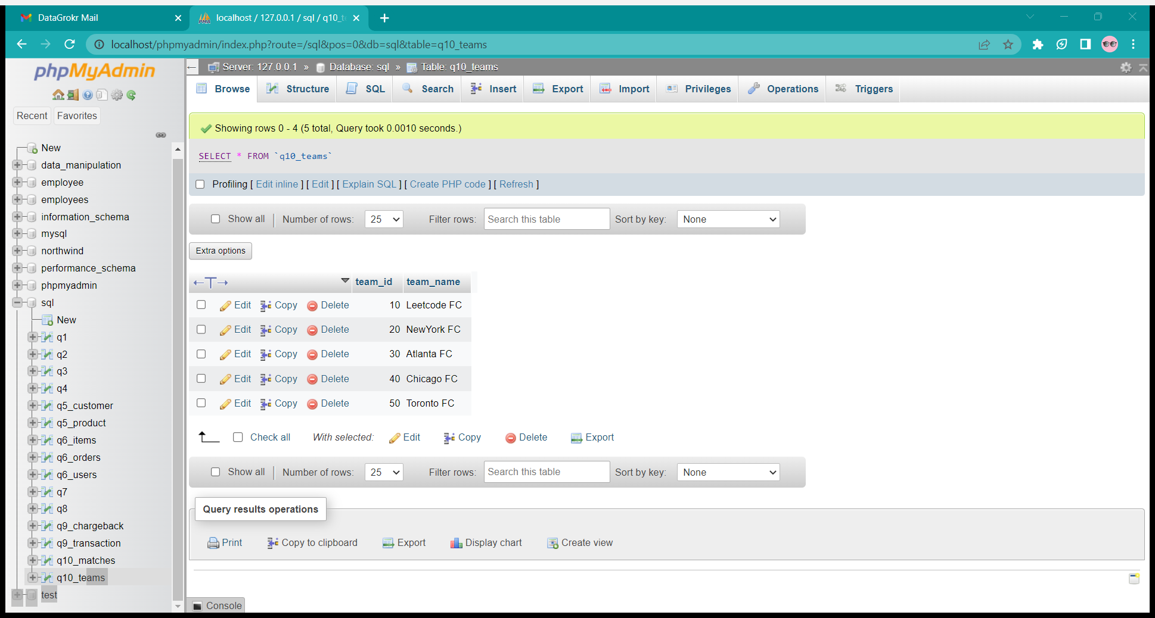

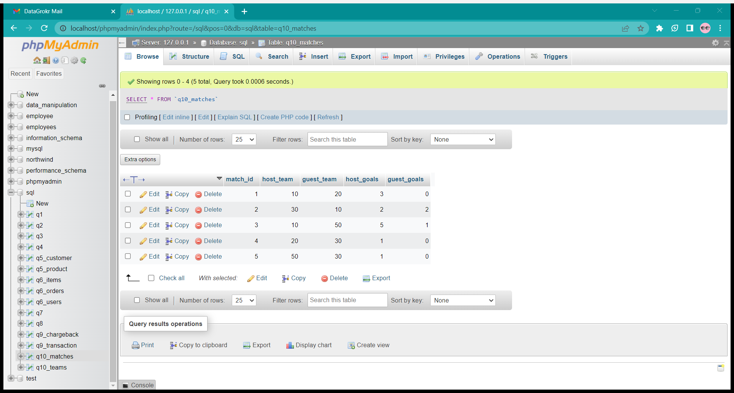

TABLES

OUTPUT

